|  |
| --- |
| Group 12 |
| Machine Learning |
| Teaching a Machine to Think like a Human |

|  |
| --- |
| Ahmet Akgun & Tim Prast  10-12-2021 |

Table of Contents

Introduction 2

Machine Learning 2

How does a Machine learn 3

Machine Learning in Our Daily Lives 5

Our Relationship with Machine Learning 5

References 7

# Introduction

“Machine learning (ML) is an umbrella term that refers to a broad range of algorithms that perform intelligent predictions based on a data set. These data sets are often large, perhaps consisting of millions of unique data points. Recent progress in machine learning has attained what appears to be a human level of semantic understanding and information extraction, and sometimes the ability to detect abstract patterns with greater accuracy than human experts” (J, et al., 2019). Essentially, Machine learning is the way by which a machine can interpret and then understand and make meaning from a large volume of data, similar to the way in which a human might. Artificial Intelligence and Machine Learning go hand-in-hand, there can not be one without at least some aspect of the other. Therefore, it is important for us to understand what Artificial Intelligence is.

As defined by Prof Dalvinder Singh Grewal, PhD; “Artificial Intelligence is the mechanical simulation system of collecting knowledge and information and processing intelligence of universe: (collating and interpreting) and disseminating it to the eligible in the form of actionable intelligence” (IOSR-JCE, 2021). It is the way by which a Machine collects, collates, and acts on information it receives from artificial sensors. What makes it different from natural intelligence is that the processing is done entirely though Artificial means and sensors.

As mentioned, one cannot have Machine Learning without some level of artificial intelligence. AI allows the information collected by a machine’s software and hardware (usually a type of sensor) to be used by the Machine to learn. The main purpose of machine learning is to maximise the self-cognition of a machine with little to no human intervention. Unlike other types of artificial intelligence, machine learning does not require intensive programming and it allows a machine to learn by itself. This allows a machine to learn by itself.

## Machine Learning

The concept of Machine Learning falls into three differing categories (IBM, 2021). In supervised learning, a machine is given a dataset and instructed to interpret the data using with a certain logic pattern. In unsupervised learning, the dataset is interpreted by the machine using a logic pattern of its own creation. Unsupervised learning does not rely on human intervention to discover hidden patterns or data grouping. Semi-supervised learning is a combination of the two. It provides the machine with a smaller dataset and a set logic pattern, which allows the machine to learn and adapt to create and form its own logic pattern to apply to future datasets. This can be useful when a machine creator only has access to smaller datasets, by exposing the machine to many smaller sets a machine can be taught more with a smaller overall exposure. An automated system capable of self-learning can predict the result of a situation, an event or a task based on the relevant information available. It uses historic data to foresee the future.

Over the recent years, machine learning has become more diversified, and each diversification has created new branches of study. Automated machine learning, Neural Networks (IBM, 2021) and Transfer Learning are currently some of the most advanced machine learning technologies and applications.

Automated machine learning simplifies data selection, processing, and extraction. This method reduces the time and resources needed to achieve the desired results. It also enables people who do not possess the knowledge or skills in machine learning to apply this technology to their field of work.

Neural networks have similar structures to the brains of animals and humans. Organic brains have neurons (nerve cells) to process then information that is received from the senses (sight, sound, taste etc.) whereas artificial neural networks are composed of nodes that compute information from non-biological sensors. Machine learning is based on a machines ability to learn from the data provided to it, but Neural Networks learn by classifying data after first processing it through their nodes, similar to the way in which a human brain operates.

Transfer learning is a method of machine learning that enables the data from a particular task to be carried to another related task. This method provides the opportunity for a machine to gain more knowledge and experience, thus making it more effective in future tasks. The machine basically learns from the repeated iterations of a given task.

## How does a Machine learn?

Data and algorithms are the two main components of machine learning technology. The sophistication of an algorithm will determine the path a machine will follow while training itself while the quality of the data the machine has access to will drastically affect the content created by a self-learning system. Implementing more mathematical and geometrical applications like statistics, probability and charting will increase the intelligence of learning machines. Further developments in data science will provide data for learning machines with higher quality and quantity. Training and employing more data analysts will help machines sort information faster and more accurately.

In essence, a machine can be programmed to learn based on the data it is fed. If you want a machine to learn to recognise a street scene and be able to navigate using modern roadways, then it must be fed the required information. In this instance, the field of study of Computer Vision is applied. Computer vision can be broken down into three separate categories, Semantic Segmentation, Image classification and Object Detection. Semantic Segmentation is giving a machine the information to “understand the structures and components of an image on a pixel level. Methods for semantic segmentation try to make predictions about the structures and objects in an image” (Marius, 2021). An example of which can be seen below.

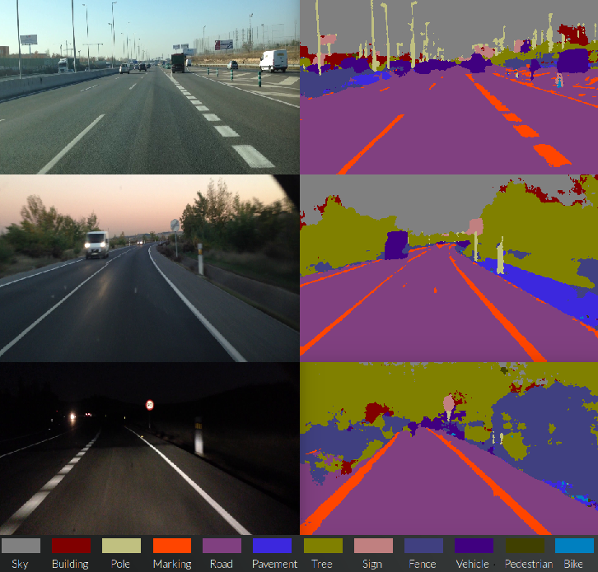

Figure 1 (Example cases of pixel wise segmentation performed by SegNet on real road scenarios, 2016) (Arroyo, 2016)

Unlike the above example of Semantic Segmentation, Image Classification focuses on the image, not on its separate parts, and classifies it using the key component of an image. Tied directly to Image Classification is Object Detection. Object Detection technology works to identify the “instances of objects of a certain class within an image.” (Marius, 2021). In this sense, Image Classification might be used to feed data of a certain data type to an Object Detection machine learning algorithm to help it develop.

See also this documents section on Autonomous Vehicles for more information relating to the Machine learning behind a vehicles autonomous future.

Natural language is a field of Machine learning that we have explored in another section of this document but is worth mentioning while we are exploring the idea of Machine Learning as a whole.

While NLP is a large field of study, “all of them (the different fields of study within NLP) try to deduct some meaning from our language and perform calculations based on our language and its components. Algorithms based on NLP can be found in various applications and industries. Just to name a few applications which you might encounter every day such as translators, social media monitoring, chatbots, spam filters, grammar check in Microsoft word or messengers and virtual assistants.” (Marius, 2021)

Deep Learning is a sub-type of Machine Learning technology and over the recent years, it has received substantial interest. It mainly benefits from image/audio processing, artificial neural networks, both supervised and unsupervised learning styles. Traditional learning machines would require an expert to set their definitions. Machines with deep structured learning can differ an object from another by analysing their appearance and voice. It also follows similar learning patterns to humans' when processing raw data.

## Machine Learning in Our Daily Lives

Although at an early stage, deep learning technology is already used in digital vocabularies, translators, self-driving vehicles and video streaming platforms. Industries like finance, electronic commerce, logistics and healthcare are widely benefitting from deep learning systems. When we browse shopping websites and view an item, similar items displayed by the web browser use deep learning technology to find those items. Another example is the anti-fraud security systems of financial organisations that detect suspicious activities by analysing live transactions and comparing that information with past transactions.

Machine learning will enhance an organisations' data processing capabilities and thus increase the productivity and profitability of a businesses. Marketing departments will have more specific information on the target demographics that would be interested in their products and they will have more up to date statistics about markets and market behaviour. Production departments will have vast technical data about the materials and techniques they will use to manufacture goods. Automated assembly lines will be assisted by not only human operators but also learning machines that will optimise power usage, material distribution and workflow. Logistic companies will have navigation systems augmented with learning machines that will create delivery routes with live traffic information to reduce the time and fuel consumption of their shipments and decrease delivery and wait times.

As the technology behind Machine Learning develops and is used more by our society, the number of employment opportunities for people who are experts in this field will certainly increase. On the other side, the need for people who provide these services manually will likely decrease as automated systems reach maturity. Organisations adopting deep learning or machine learning technology in general will constantly be challenged with developmental obstacles such as the cost of maintenance and experimentation in real-life scenarios and finding the correct datasets. In time new methods and techniques will rise that will enhance machine learning in every aspect and make it more affordable and feasible for both individuals and organisations.

## Our Relationship with Machine Learning

Today, Virtual Assistants and Chatterbots already present on certain websites are powered by Machine Learning and Natural Language processing. When we enter our questions into a chatbots they can understand what our inquiry is about by detecting and processing keywords – this is after being fed and learning from large datasets of Natural Language libraries and human to human text-based interactions. This service saves the both the Business and the Customer a significant amount of time by reducing the need for human-to-human interactions or waiting in virtual (or phone line) queues.

At this early stage, Machine Learning and NLP in particular is not able to fully comprehend or grasp our linguistic meanings in certain situations but as develop, they will become much more efficient assistants. Once further developed, NLP

The goods we purchase from online-stores will reach our homes quicker through Machine learned optimised routes of delivery. We will be provided more accurate delivery time-lines and will even be able track an items route in real-time.

When protective programs that defend our IT devices from malicious software are augmented with deep learning machines, they will provide an even greater line of defense. By reacting in real-time based on thousands of different Dataset scenarios, Machine taught anti-virus programs will be able to better identify and defend as ill-intended hackers attempt to infiltrate a person’s IT system. By being one step ahead of attackers these programs will operate in both a proactive and protective manner.

Artificial Intelligence, Machine Learning and Deep Learning are inter-related technologies. As one advances so, the others benefit from that advancement. Developments in these areas will make our digital and personal lives faster, safer and more affordable. They will also create new fields for innovation in other areas of Information Technology.

# References

Arroyo, R., 2016. *Research Gate.* [Online]   
Available at: https://www.researchgate.net/profile/Roberto-Arroyo-4/publication/304789242/figure/fig2/AS:380415174037504@1467709453041/Example-cases-of-pixel-wise-segmentation-performed-by-SegNet-on-real-road-scenarios.png  
[Accessed 12 October 2021].

IBM, 2021. *Ibm.com.* [Online]   
Available at: https://www.ibm.com/cloud/learn/machine-learning  
[Accessed 12 October 2021].

IBM, 2021. *Ibm.com.* [Online]   
Available at: https://www.ibm.com/au-en/cloud/learn/neural-networks  
[Accessed 12 October 2021].

IOSR-JCE, 2021. A Critical Conceptual Analysis of Definitions of Aritifical Intelligence as Applicable to Computer Engineering. *IOSR Journal of Computer Engineering,* 16(2), p. 13.

J, N., H, C. & M, B., 2019. Machine Learning: Applications of Artifical Intelligence to Imaging and Diagnosis. *Biophysical Reviews,* 11(1), pp. 111-118.

Marius, H., 2021. *Toward Data Science.* [Online]   
Available at: https://towardsdatascience.com/overview-state-of-the-art-machine-learning-algorithms-per-discipline-per-task-c1a16a66b8bb  
[Accessed 12 October 2021].